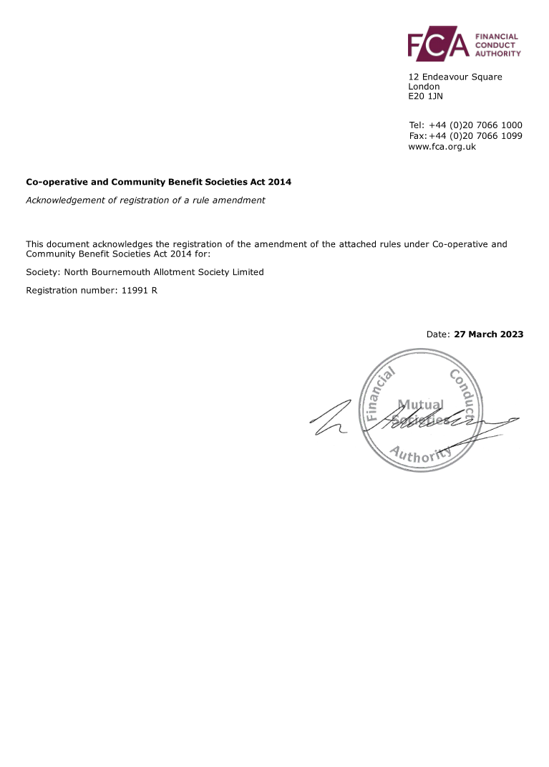

REGISTERED RULES OF THE

NORTH BOURNEMOUTH ALLOTMENT SOCIETY LIMITED

Registered under the Co-operative and Community Benefit Societies Act 2014
Registration Number: 11991R
Registered Office: North Bournemouth Allotment Society Limited, Cornelia Road, Bournemouth, Dorset, BH10 4FG
All previous Rules rescinded

List of Rules

- Name

- Registration

- Registered Office

- Use of Name

- Objects and Powers of the Society

- Management Structure and Organisation

- Membership

- Membership Agreement

- Shares

- Voting Rights

- Meetings

- Membership Subscriptions

- Financial Affairs

- Copies of Rules

- Amendment and Application of Rules

- Indemnity

- Dissolution

- Disputes

- Byelaws

1. NAME

1.1 The name of the organisation shall be North Bournemouth Allotment Society Limited. Hereafter referred to as the Society.

2. REGISTRATION

2.1 The Society is registered under the Co-operative and Community Benefit Societies Act 2014 (“the Act”).

3. REGISTERED OFFICE

3.1 The Registered Office of the Society shall be located at North Bournemouth Allotment Society Limited, Cornelia Road, Bournemouth, Dorset, BH10 4FG. In the event of any change in the situation of the Registered Office, notice shall be sent to the Registrar within fourteen days.

4. USE OF NAME

4.1 The registered name of the Society shall be mentioned in legible characters in all business letters of the Society and in all bills of exchange, promissory notes, endorsements, cheques and orders for money or goods purporting to be signed by or on behalf of the Society and in all bills, invoices, receipts and letters of credit of the Society. Any documentation or publication produced, or statements made under the heading of the Society must be approved by its Management Committee or under powers delegated by it.

5. OBJECTS AND POWERS OF THE SOCIETY

5.1 The objects of the Society are to:

5.1.1 Manage the North Bournemouth allotment site.

5.1.2 Promote allotment gardening as a community resource, encouraging participation and membership.

5.1.3 By various means further the interests of Members with regard to the proper cultivation, good management and safe enjoyment of the allotments.

5.2 The Society shall have the power to do all lawful things necessary or expedient to further its objects and in particular has the power to:

5.2.1 Take measures to protect Members and the site against damage, trespass, and theft.

5.2.2 Maintain the site and the facilities and if necessary erect, pull down, repair, alter or otherwise deal with any buildings thereon.

5.2.3 Collect, provide, publish and distribute any information, guidance and advice relating to allotment and leisure gardening by appropriate forms of communication including electronic means.

6. MANAGEMENT STRUCTURE AND ORGANISATION

6.1 The Governance of the Society shall be vested in the Annual General Meeting (“AGM”) whilst day to day management of the affairs and property of the Society is delegated to the Management Committee.

6.2 At the AGM Members shall elect a Chairperson, Secretary and Treasurer for the Society and in addition, other Members will be elected at the AGM, to fulfil other Committee roles such as are considered appropriate at that time. The Management Committee shall comprise of not fewer than seven Members and not more than twenty.

6.3 Prior to each AGM all Members shall be given the opportunity to stand as a candidate for a Management Committee role. In the event of there being more than one candidate for a particular role the outcome shall be determined by a ballot of the Members present at the AGM. Management Committee Members shall be eligible to stand for re-election each year.

6.4 The Management Committee shall be able to co-opt any additional Members, including Co-workers, to fill vacancies or additional roles, during the year.

6.5 Tenure of any post as a Committee Member shall be voluntary, unpaid, and open only to Members of the Society. Arrangements will be put in place by the Committee for the reimbursement of appropriate and legitimate out of pocket expenses.

6.6 The Chair, Secretary, Treasurer and other elected Members of the Management Committee shall keep accurate records of their dealings on behalf of the Society, which shall be available for inspection by Members.

6.7 A quorum for the Management Committee shall consist of seven Members including two of Chair, Secretary or Treasurer.

7. MEMBERSHIP

7.1 Membership shall be open to the following persons and bodies who support the objects of the Society.

7.1.1 Plot Holding Members who have paid the appropriate annual subscription for their plot.
7.1.2 Non-shareholding Members (i.e., Co-workers) named by Plot holding Members in their Tenancy Agreements

7.2 Allocation of Membership

7.2.1 Membership shall be open to such persons as may be admitted by the Management Committee from time to time.

7.2.2 The Management Committee shall have the right to, for good and sufficient reason, reject an application for membership.

7.3 Extraordinarily, any Member may be asked to relinquish their membership of the Society by resolution of a majority of Members present at a General Meeting. In this event the Member to whom the expulsion applied would have previously been given at least one verbal request by a spokesperson of the Management Committee and at least one letter from the Management Committee setting out the issue at hand and its referral to a General Meeting if not satisfactorily resolved within a reasonable and set time period.

7.4 A Member shall cease to be a Member in the following eventualities:

7.4.1 The death of the Member

7.4.2 The expulsion of the Member under Rule 7.3

7.4.3 The withdrawal of the Member from the Society by sending notice in writing to the Society Secretary at the Registered Office of the Society.

7.4.4 The non-payment of a member’s annual subscription for a period of 40 days after it becomes due, terminates membership.

7.5 A Member may withdraw from the Society by sending notice in writing to the Secretary at the Registered Office of the Society. Upon withdrawal, all sums paid by the Member on account of shares shall be forfeited and the Member's share shall be extinguished.

7.6 Proceedings on Death or Bankruptcy – Upon a claim being made by:

7.6.1 The personal representative of the deceased Member; or

7.6.2 The trustee in bankruptcy of a Member who is bankrupt: or

7.6.3 The Office Holder to any property in the Society belonging to such a Member,

the Society shall transfer or pay property to which the Office Holder has become entitled as the Office Holder may direct them.

7.6.4 A Member may in accordance with the Act, nominate any individual or individuals to whom his/her property in the Society at the time of his/her death shall be transferred, but such nomination shall only be valid to the extent of the amount for the time being allowed in the Act. On receiving a satisfactory proof of death of a Member who has made a nomination the Society shall, in accordance with the Act, either transfer or pay the full value of the property comprised in the nomination to the individual or individuals entitled thereunder.

8. MEMBERSHIP AGREEMENT

All Members shall agree in writing, to:

8.1 Accept the Rules and Byelaws of the Society and to abide by the terms and conditions contained therein.

8.2 Adopt plot and site management practices as set by the Management Committee and agreed by a majority of Members at a General Meeting.

9. SHARES

9.1 Every Member admitted under Rule 7.1.1 shall hold one non-withdrawable share, which is not transferable. The share shall have the nominal value of £1 payable in full by a Member on joining the Society.

9.2 One share shall be the maximum shareholding of any Member.

10. VOTING RIGHTS

10.1 Each share-holding Member i.e., all Plot Holding Members, shall be entitled to one vote at Society meetings.

10.2 At all General meetings of the Society or at Committee Meetings proposals shall be decided by a majority of votes and if the votes are equal the Presiding Officer shall have a casting vote in addition to his vote as a Member.

10.3 The Chair, or if not present, a Chairperson elected at any General meeting or Committee meeting, shall preside.

11. MEETINGS

11.1 The Society shall in each year hold an AGM at such time and place, as the Management Committee shall determine. Not more than 15 months shall elapse between the date of one AGM and that of the next.

11.2 The Committee may also convene further General Meetings as deemed necessary.

11.3 Members will be given at least 14 days’ notice of the AGM and other General Meetings.

11.4 Extraordinary General Meetings may be called by either a quorum of the Management Committee, or by written request from a Member which states the reason for the meeting and is signed by at least 25 Plot Holding Members. Such request to be delivered to the Society Secretary at the Registered Office. The business of the Extraordinary General Meeting will be restricted to items on the original request with no amendments being accepted. Details will be notified to Members, along with notice of the meeting, at least 14 days prior to the meeting date.

11.5 No business shall be transacted at any General Meeting unless a quorum is present. The quorum at any General Meeting shall be 25 Plot Holding Members including two of the Chair, Secretary and Treasurer.

12. MEMBERSHIP SUBSCRIPTIONS

12.1 At the General Meeting/AGM held nearest to and prior to December 31st in each year the Management Committee shall seek approval for any changes to the Membership Subscriptions due in the following January.

12.2 Membership Subscriptions for the calendar year are due to be paid no later than 31st January. Failure to pay on time can lead to termination of Membership in accordance with Rule 7.4.4.

13. FINANCIAL AFFAIRS

13.1 The Society is a non-profit making organisation and all surplus funds arising from the business of the Society shall be used for the furtherance of the objects of the Society.

13.1.1 The Society shall have the power to borrow money from its Members and others to further its objects, providing the amount outstanding at any one time does not exceed £30,000.

13.1.2 The Society shall have the power to mortgage or charge any of its property including assets and undertakings of the Society, present and future and issue loan stock, debentures and other securities for money borrowed or for the performance of any contracts of the Society or its customers or persons having dealings with the Society.

13.1.3 The rate of interest on money borrowed, except on money borrowed by way of bank loan or overdraft or from a finance house or on mortgage from a building society or local authority, shall not exceed 5% per annum or 2% above the Bank of England base rate at the commencement of the loan, whichever is the greater.

13.1.4 The Society may receive from any person donations or loans free of interest, in order to further its objects, but shall not receive money on deposit.

13.2 The shares held by Members shall not carry any interest and shall not confer any right to a dividend.

13.3 The Society Secretary shall register every issue or cancellation of shares by making an appropriate entry in the register of Members relating thereto.

13.4 Upon withdrawal from Membership all sums paid by the Member on account of shares shall be forfeited and the Member's share shall be extinguished.

13.5 The Management Committee may open Bank or Building Society Accounts in the name of the Society in which shall be lodged all monies received on behalf of the Society. These accounts shall be used to administer and record funds received and disbursed on behalf of the Society. Any funds available for term investment may be invested to earn interest with a bank or building society on the recommendation of the Committee and on approval by a majority of Members at a General Meeting.

13.6 At the conclusion of each financial year the Treasurer shall complete accounts and a balance sheet for presentation and approval at the AGM. After approval the revenue accounts and balance sheet must be signed by the Secretary and two Committee Members of the Society acting on behalf of the Society's Committee.

13.7 Within the time allowed by legislation the Secretary will send to the Financial Conduct Authority an Annual Return of the Society's affairs (in the form prescribed by them) accompanied by the signed copy of the accounts and balance sheet, referred to in Rule 13.6

13.8 Auditing of Society accounts and balance sheet:

13.8.1 The Members shall vote annually at each Annual General Meeting, as allowed by Section 84 of the Co-operative and Community Benefit Societies Act 2014 to have, when necessary in law or where the membership requires:

- An audit carried out by a qualified auditor
- An audit carried out by two or more lay auditors
- A report by a qualified auditor
- Or unaudited accounts, where the conditions for such exist

13.8.2 If a full audit or a report is required, a person who is a qualified auditor under section 91 of the Co-operative and Community Benefit Societies Act 2014 shall be appointed. The qualified OR lay auditors, if so appointed, shall not be officers or servants of the Society and nor shall they be partners of, or in the employment of, or employ, an officer or servant of the Society. Lay auditors shall be chosen by the Committee of Management from the general Membership and / or others.

13.8.3 If the Membership vote for unaudited accounts, the Society’s income and expenditure ledger shall be scrutinised by the Secretary and the Committee Members only and signed, as a true record, by the Secretary and two Committee members or any other number as may be required by legislation. An income / expenditure report will be prepared to present to the Society’s Members at each AGM.
14. COPIES OF THE RULES

14.1 It shall be the duty of the Committee to supply free of charge to all Members a copy of the current Rules which may be delivered by email or by delivery of a hard copy. Where a Member has already been provided with a copy there may be a charge of up to £5 for a second copy (under s18 of the 2014 Act).

15. AMENDMENT AND APPLICATION OF RULES

15.1 Changes to the Rules of the Society (i.e., new Rules made, Rules amended or rescinded) may only be made at a General Meeting and when a majority of all votes cast (in person, by proxy and postal) are for approval of the change.

15.2 No new Rule or amendment of a Rule is valid until registered with the Financial Conduct Authority in accordance with the 2014 Act.

15.3 The Society shall be run in accordance with its registered Rules.

16. INDEMNITY AND INSURANCE

16.1 Every Member of the Committee shall be indemnified by the Society against all losses and liabilities incurred by him/her in relation to the execution of his/her Office providing that nothing in this clause shall entitle him/her to any indemnity against liability arising through negligence or fraud or similar actions on his/her part.

16.2 The Society may decide to purchase and maintain insurance, at the expense of the Society, for the benefit of any current or former member of the Management Committee of the Society in respect of any loss or liability which has been caused by such a member in connection with their duties or powers in relation to the Society.

17. DISSOLUTION

17.1 The Society may at any time be dissolved by the consent of three-fourths of the Members testified by their signatures to an instrument of dissolution in the form prescribed in the 2014 Act.

17.2 If on winding up or dissolution of the Society any of its assets remain to be disposed of after its liabilities are satisfied, none of these assets shall be distributed among the Members but should be passed to a similar organisation.

18. DISPUTES

18.1 In the event that a Member or Members find themselves in dispute with the Society over a Committee decision, they may lodge an Appeal through the Society's internal appeals process, as detailed in the Byelaws and other policy documents. Should the Committee not bring the parties to agreement, the matter in dispute may be submitted to the arbitration of the Officer appointed by Bournemouth, Christchurch and Poole Council, whose decision shall be final and binding on both parties thereto.

19. BYELAWS

19.1. Byelaws The Committee may from time to time make Byelaws relating to the tenancy and management of allotment gardens, provided that no such Byelaws are inconsistent with these Rules.

